SHIRE OF JERRAMUNGUP

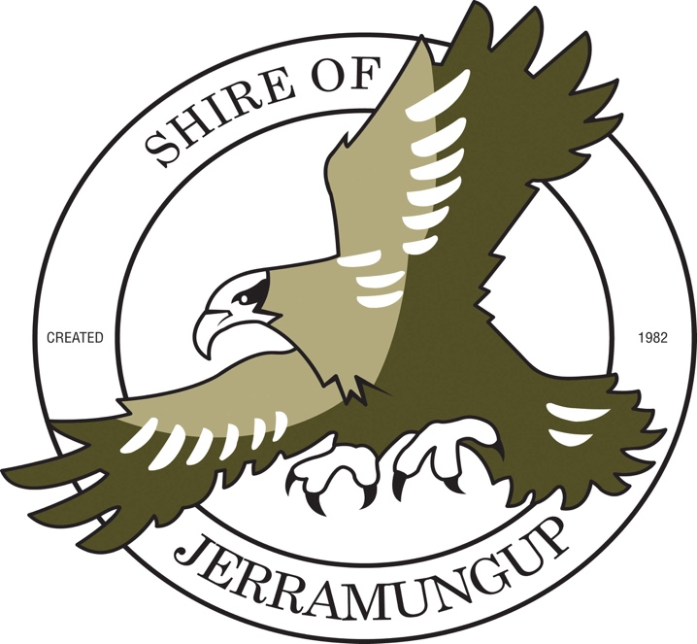

MINUTES

ANNUAL MEETING OF ELECTORS

16th December 2015

SHIRE OF JERRAMUNGUP

MINUTES OF THE MEETING OF ELECTORS HELD IN THE COUNCIL CHAMBERS, JERRAMUNGUP ON WEDNESDAY 16TH DECEMBER 2015 AT 10.25AM

MINUTES

- OPEN AND WELCOME

The Shire President declared the meeting open at 10:25am.

- RECORD OF ATTENDANCE

Cr R Lester Shire President
Cr J Iffla Deputy Shire President
Cr R Parsons Councillor
Cr J Leenhouwers Councillor
Cr W Bailey Councillor
Cr C Daniel Councillor

Mr B Bailey Chief Executive Officer
Mr C Pursey Planning Officer

- APOLOGIES

Cr B Trevaskis Councillor

- PUBLIC QUESTION TIME

Nil

- CONFIRMATION OF PREVIOUS MEETING MINUTES

Moved Cr Parsons / Seconded Cr Daniel

That the minutes of the Annual Electors Meeting of 2nd February 2015 be received.

Carried unanimously

- BUSINESS ARISING FROM PREVIOUS MINUTES

Nil

- RECEIVAL OF SHIRE PRESIDENT’S REPORT AND CHIEF EXECUTIVE OFFICER’S REPORT

Moved Cr Leenhouwers / Seconded Cr Iffla

That the Shire President’s and Chief Executive Officer’s report be received.

Carried unanimously

- RECEIVAL OF ANNUAL FINANCIAL REPORTS AND AUDITOR’S REPORT
Moved Cr Leenhouwers / Seconded Cr Parsons

That the Annual Financial Report for 2014/2015 be received as presented.

Carried unanimously

- GENERAL BUSINESS

Nil

- CLOSURE

The Shire President declared the meeting closed at 10:27am.

